Lab 8
Dated: February 3, 2025

Task # 1 (Signature)

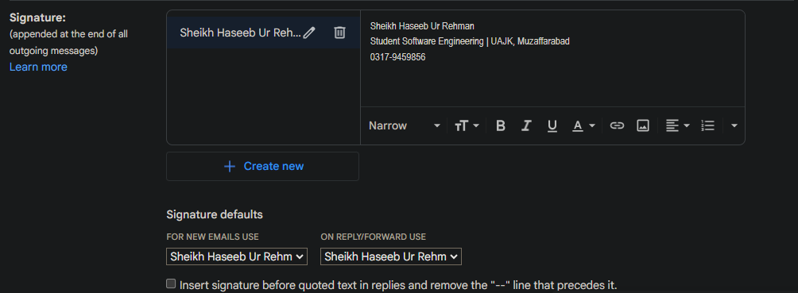

Task # 1 (Labels)

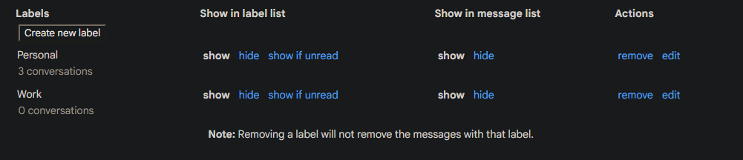

Task # 2 (Composed E-mail)

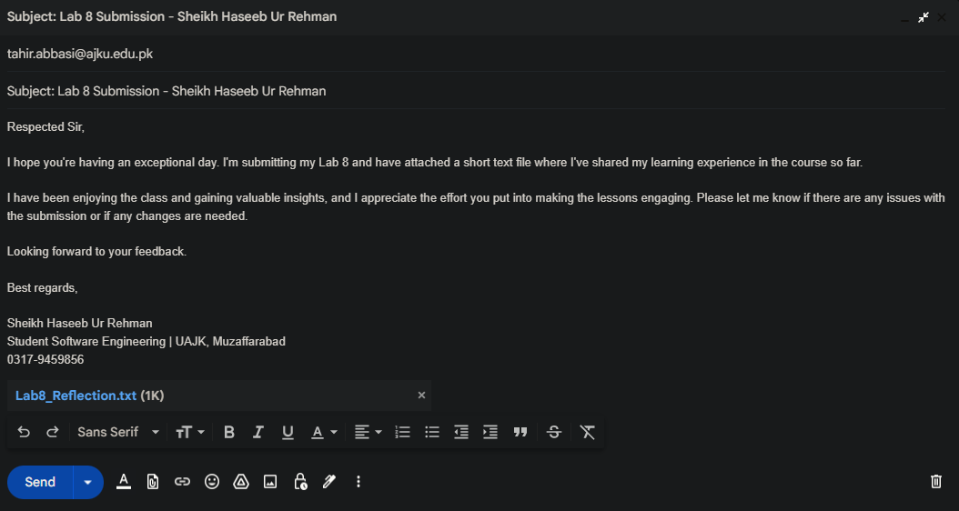

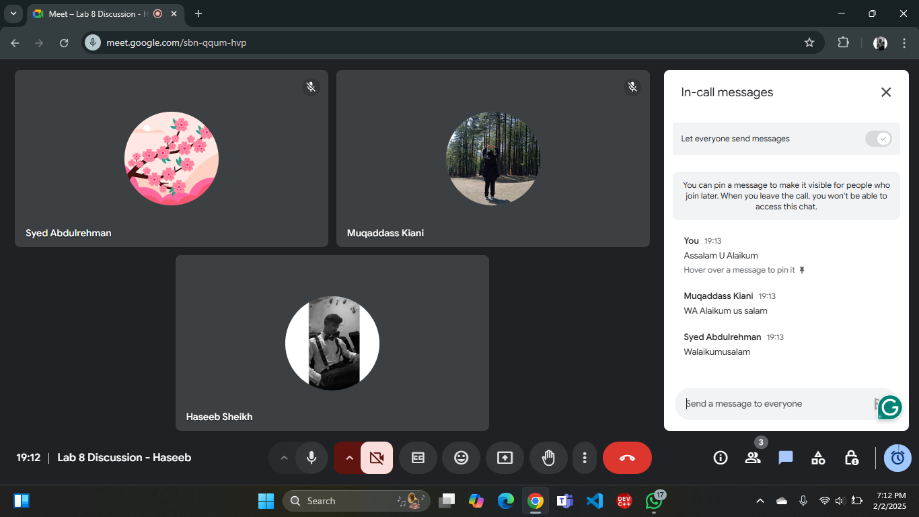
Task # 3 (Google Meet In-Call Chats)
Task # 3 (Screen Sharing)

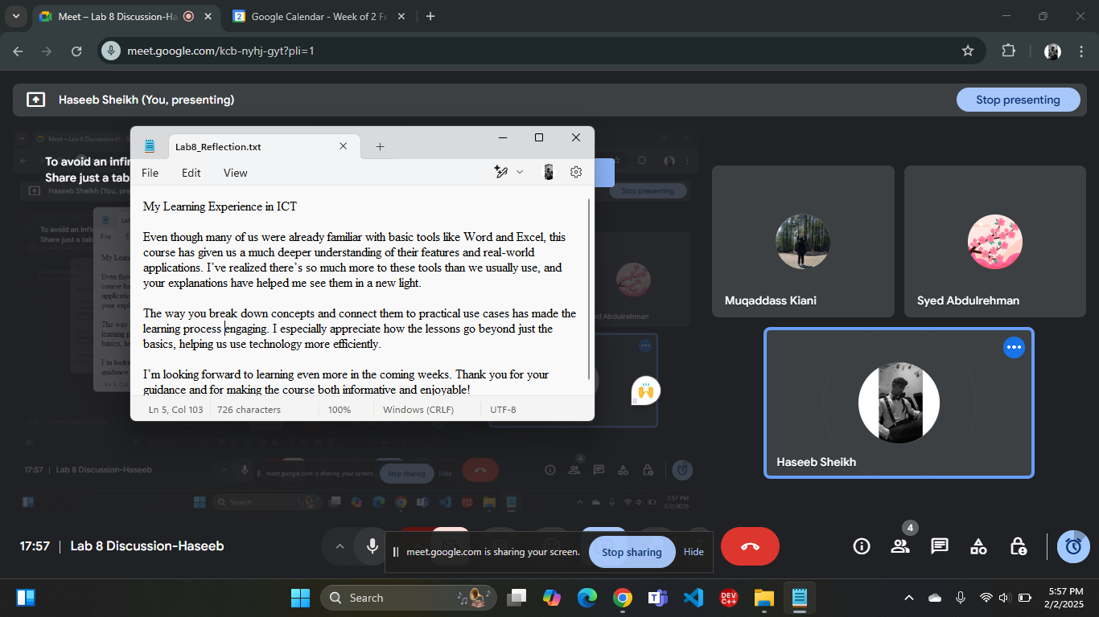

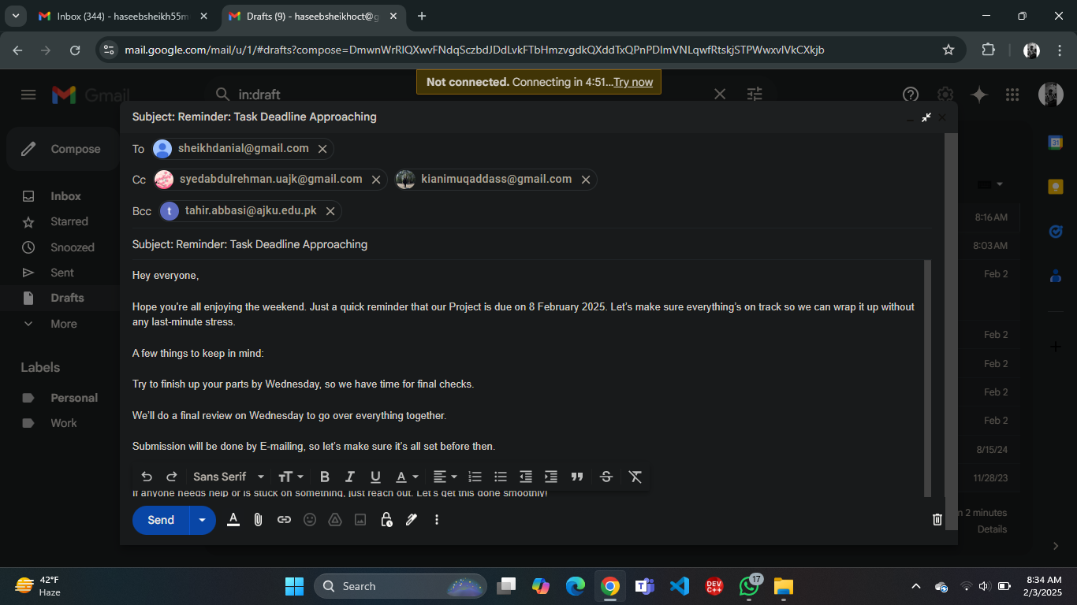
Task # 4 (Cc and Bcc)
Task # 5 (Flawed E-mail)
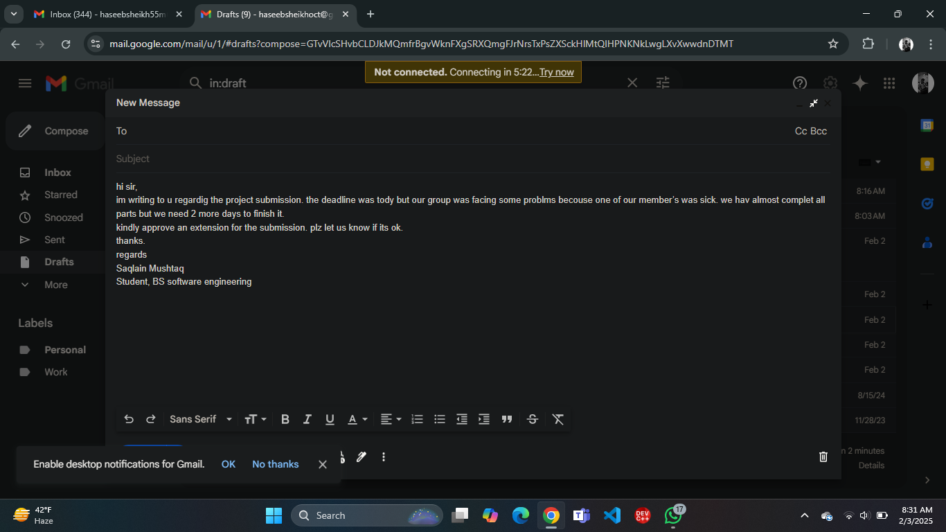

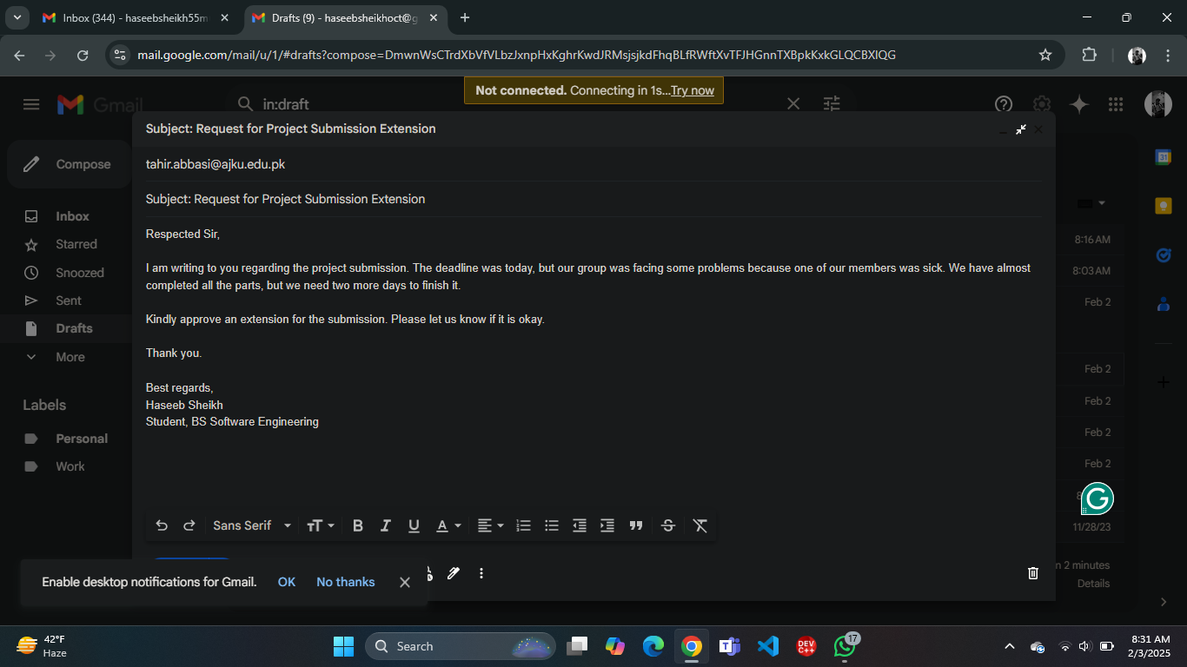
Task # 5 (corrected E-mail)

